Placental Atlas Quantifying Notes

Number of NK Cells

If the macro protocol is not working to highlight the NK cells correctly for counting, please use these manual instructions to count the cells accurately.

* #NK cells
* Drag the merged file from the drive and drop into Fiji

1. Find image from menu and locate type, then select RGB stack

(This stacks the stains the way we want, also picture turns B+W)

* + Image > Color > Split Channels

1. Choose the mCherry channel (red), and duplicate it. This is the one you will work on. You can title it “mCherry”
   * Image > Duplicate
2. Threshold and make NK cells red
   * Image > Adjust > Threshold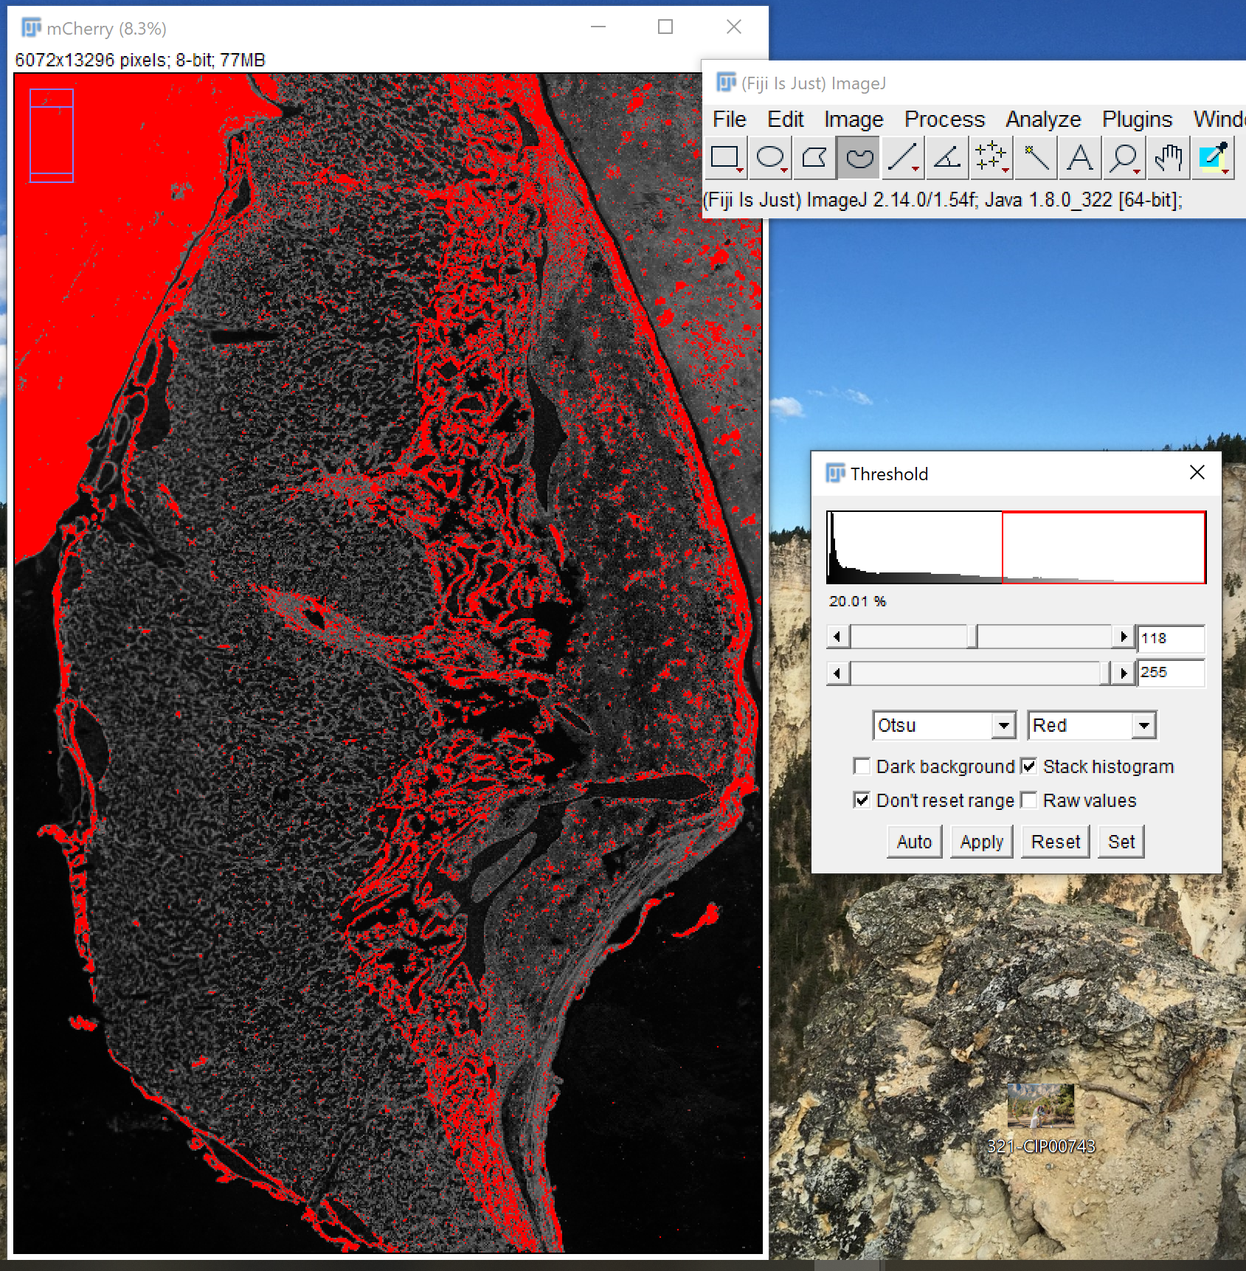
   * Otsu default
   * The top slider will be at 240, and the bottom at 255 for *most* images. Sometimes, there are images with excessive red staining surrounding the placenta, and the top slider needs to be turned down (near 118 *may* work). (see image)
   * Set
3. \*You only need to do this step once, and it will be retained\* Go and find ‘set measurements'.
   * Analyze > Set Measurements

Make sure everything below is checked off, nothing else:

* + Area
  + Perimeter
  + Fit Ellipse
  + Display Label
  + Limit to threshold

1. Make a mask→black background and white points
   * Edit > Selection > Create Mask
2. Watershed, Erode, and Dilate
   * Process > Binary > Watershed
   * Process > Binary > Erode
   * Process > Binary > Dilate
3. Crop out excess tissue and focus only on the NK cell mass to collect measurements. Draw a line around all of the NK cells. You can look at the mCherry jpg file for comparison to make sure that you’re encompassing all of the NK cells.
   * Select ‘Freehand selection’ from toolbar 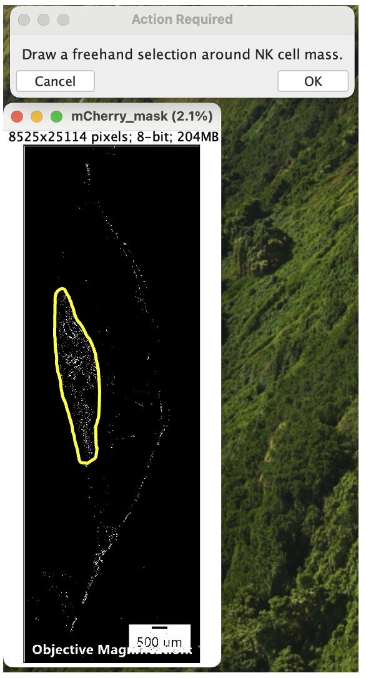
   * Trace around the entire NK cell mass (see image). Be cautious and avoid areas that are not NK cells.
   * Leave this selection for the next step
4. Analyze Particles
   * Analyze > Analyze Particles
   * Size (pixel^2): 50-15000
   * Circularity: 0.00-1.00
   * Show: Outlines
     + - Display results
       - Summarize
       - Add to manager
5. Record
   * Number of NK cells from the “Count” column in the Summary window
   * Average size of NK cells from the “Average Size” column in the Summary window

Decidua Area

* Convert the area of pixels into um
  + Use the line tool to measure the line on the burn in information (500 um = 768.006 pixels). “Control m” to get the length
  + To measure in um instead of pixels:
    - Analyze > Set Scale > fill out window:
    - Conversion: 1.5320 pixels/um
    - 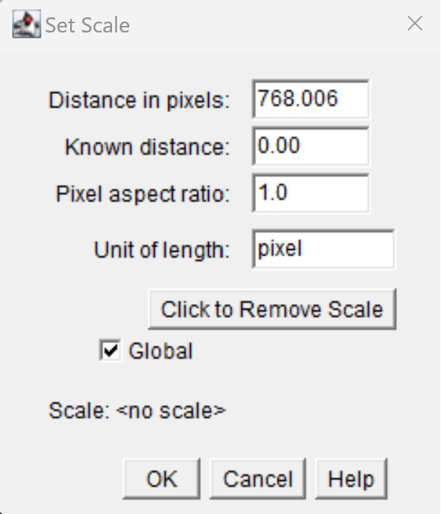
* Use the drawing feature on imagej
  + 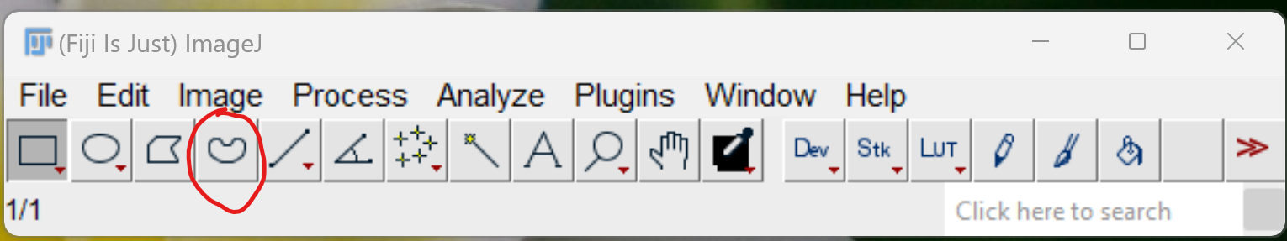
* Draw out the decidua border
* “Control m” to get the measurements

Decidual area NK cells

Decidual Depth

* Use the con
* How many slides did I stain: 14 completed, 4 more to complete, 18 total
* Start more quantifying with a lil more vigor
* For depth, make sure using same technique for each line (ie. use the outer edge on the cells)
  + Disidual area
* Line length (burn in info)--> 768.059 pixels = 500 um.
* To measure in um instead of pixels:
  + Analyze > Set Scale > fill out window:
  + Conversion: 1.5360 pixels/um
  + 
* Trophoblast cells should be green
* Avg size NK cells:
  + Check ellery’s protocol
* Test to see if we can use ellery’s procedure on trophoblasts cells (use the thresholding on GFP slide instead of mcherry)

